Data Model: OutSales

Dimensions

|  |  |  |
| --- | --- | --- |
|  |  |  |
|  |  |  |
|  |  |  |

Facts:F_Outsales

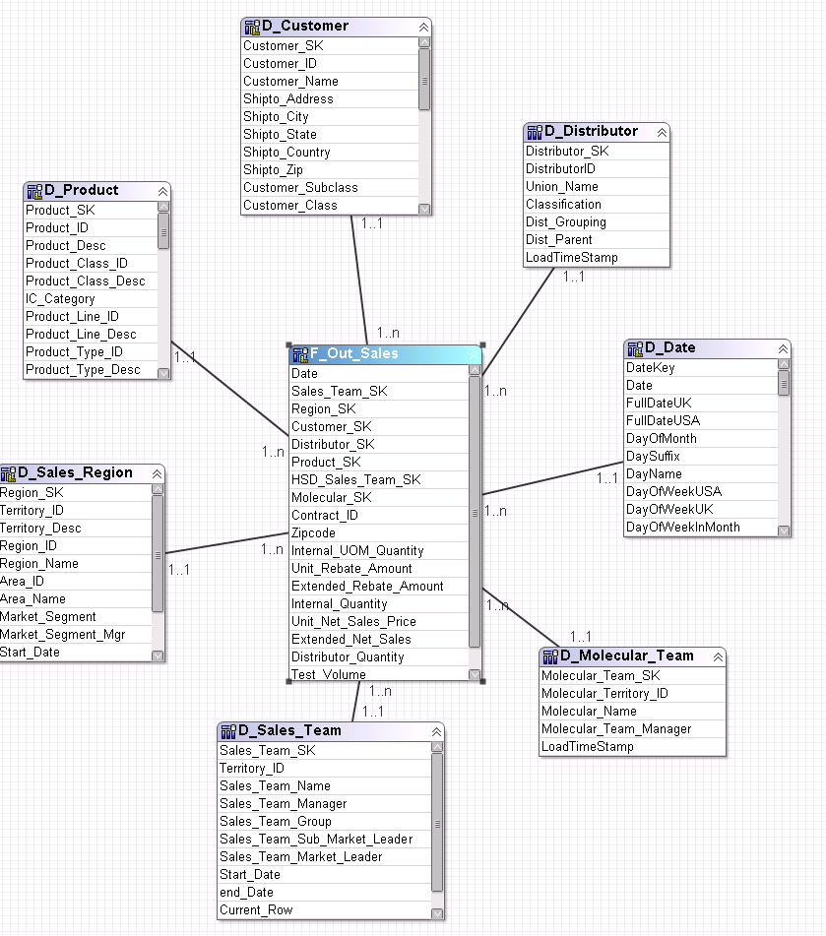

F_Sales_Plan

